**LAB -2**

**MORE QUERIES ON INSURANCE DATABASE**

**Question**

**(Week 2)**

- PERSON (driver_id: String, name: String, address: String)

- CAR (reg_num: String, model: String, year: int)

- ACCIDENT (report_num: int, accident_date: date, location: String)

- OWNS (driver_id: String, reg_num: String)

- PARTICIPATED (driver_id: String,reg_num: String, report_num: int, damage_amount:

int)

- Display the entire CAR relation in the ascending order of manufacturing year.

- Find the number of accidents in which cars belonging to a specific model (example

'Lancer') were involved.

- Find the total number of people who owned cars that were involved in accidents in 2008.

**Schema Diagram**

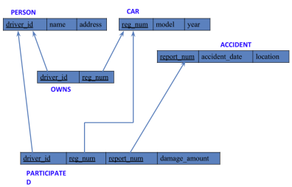

**Queries**

**● Display the entire CAR relation in the ascending order of manufacturing year.**

select * from car_101

order by year asc;

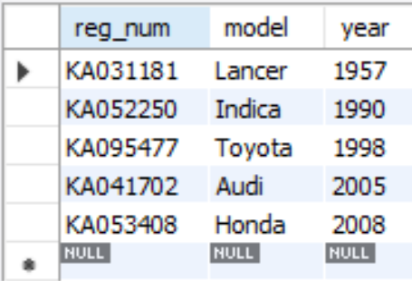

**● Find the number of accidents in which cars belonging to a specific model**

**(example 'Lancer') were involved.**

select count(report_num)

from car_101, participitated_101

where car_101.reg_num=participitated_101.reg_num and car_101.model='Lancer';

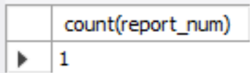

**TO DO:**

**● Find the average damage amount**

select avg(damage_amount) from participitated_101;

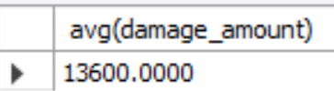

**● Delete the tuple whose damage amount is below the average damage amount**

select name

from person_101, participitated_101

where person_101.driver_id = participitated_101.driver_id and participitated_101.damage_amt > (select avg(damage_amount) from participitated_101);

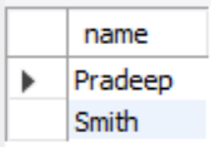

**● Find maximum damage amount.**

select max(damage_amount) from participitated_101;

